

**HCI 598  
Ashley Otero  
M4: Prototype**

**Department of Energy Regional Test Centers Data Project**

# Prototyping Strategy

## 1.1 Fidelity

For this milestone, I chose to develop a high-fidelity web-based prototype. First, I was able to access actual data, which was a welcome yet unexpected push forward in this project. Second, I often work faster in code, as it allows me to more easily iterate on versions after receiving user feedback. Third, using code allows for reusability later within the project and is a more effective use of my time. In my personal work experience, my original prototype sketches are always in a notebook on paper, using pen/pencil and occasionally a straightedge. From there, I jump right into code. I believe in the programming best practice of “don’t repeat yourself,” and I try to use abstraction methods modularize my code into unique and reusable components as much as possible (Wilson, et al., 2014).

This process was much more straightforward than a typical design process involving multiple people and groups, which allowed me to charge forward in the direction I saw was easiest and most time-saving. Since I am a one-person design and development team for the purposes of this project, I was not hampered by the design-by-committee mentality, or the difficulty in waiting for a designer to finish their wireframes/mockups before handing them to me to code.

Since I had access to real data, I decided to create a high-fidelity prototype as using real data in a test application is “essential for understanding how the proposed design matches the needs of target users.” (Roth, Hart, Mead, & Quinn, 2016) This type of prototype allows the users to see the interactions more clearly, and doesn’t require them to make their own interpretations of how the system will behave. Since many of the users I am collaborating and interacting with do not have a background in design or development, it was critical to be mindful of this while creating my prototype. I wanted to avoid any potential pitfalls, including having my users find bottlenecks on sketches or wireframes because they were unable to see the eventual flow between screens. Presenting a complete, though limited in scope, version of the end system would be more valuable to them for assessing success or failure in the design, and more useful to me as a starting point for building the actual application.

Additionally, using a high-fidelity prototype allows users to set their expectations for the end product by framing the interface in a more realistic situation. Since the prototype has a more realistic system response, it doesn’t break the user flow between action and response time (Pernice, 2016).

# Prototype Description

## 2.1 Features and Screens

The main horizontal header for the entire application is simplistic and features only two basic colors: the orange-red contained in the logo, a matching top border, and the dark grey of the text. On the left-hand side, I used the existing Regional Test Centers logo (subject to change before the end of this fiscal year) and branding. On the right-hand side, I linked to the four sites that we have data for – New Mexico, Florida, Nevada, and Vermont, as well as adding a link back to the main RTC web site. This header persists across all pages within the application.

The home page is also very simple, as it shows an embedded Google Map with dropped pins locating each of the RTC sites we are showing publically-collected data on. Once a user selects a site from either the map or the top level navigation, they are directed to the individual site page for their selection.

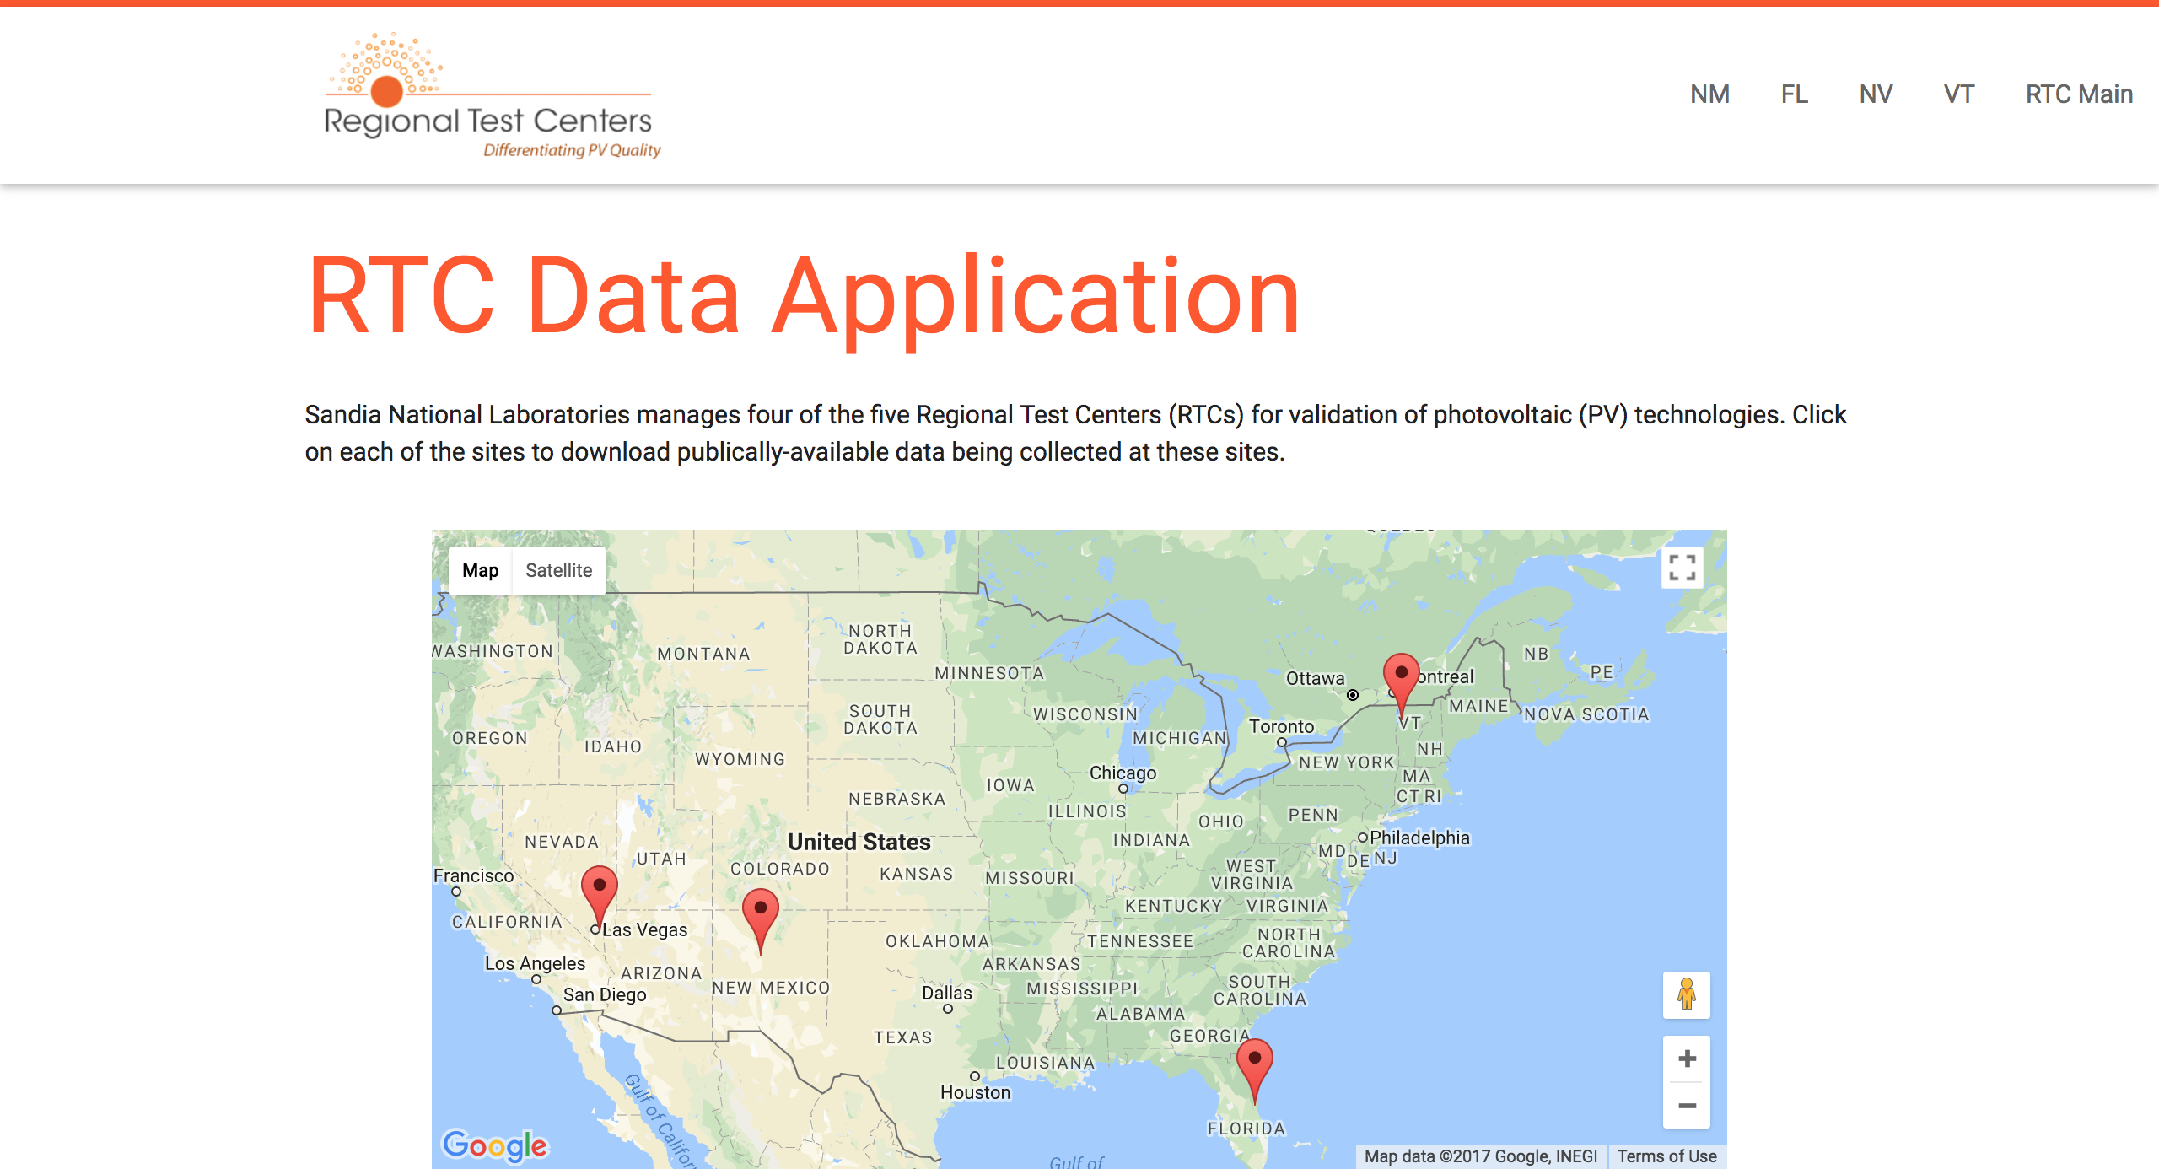

Figure : RTC Data Home Page

The individual site page contains many details, including: location, technical specifications, photos, and climate data. This page also contains both systems (weather and baseline) as well their respective data types.

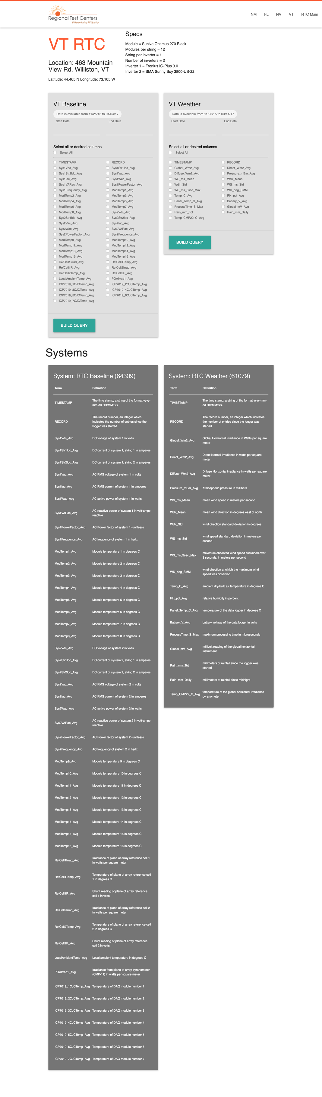

Figure 2: Site specific query builder

The user has the option to select a date range from within either available system. The system automatically queries the database for the limits of available data, as shown in the “Data is available from ##/##/#### to ##/##/####” rounded box within each system.

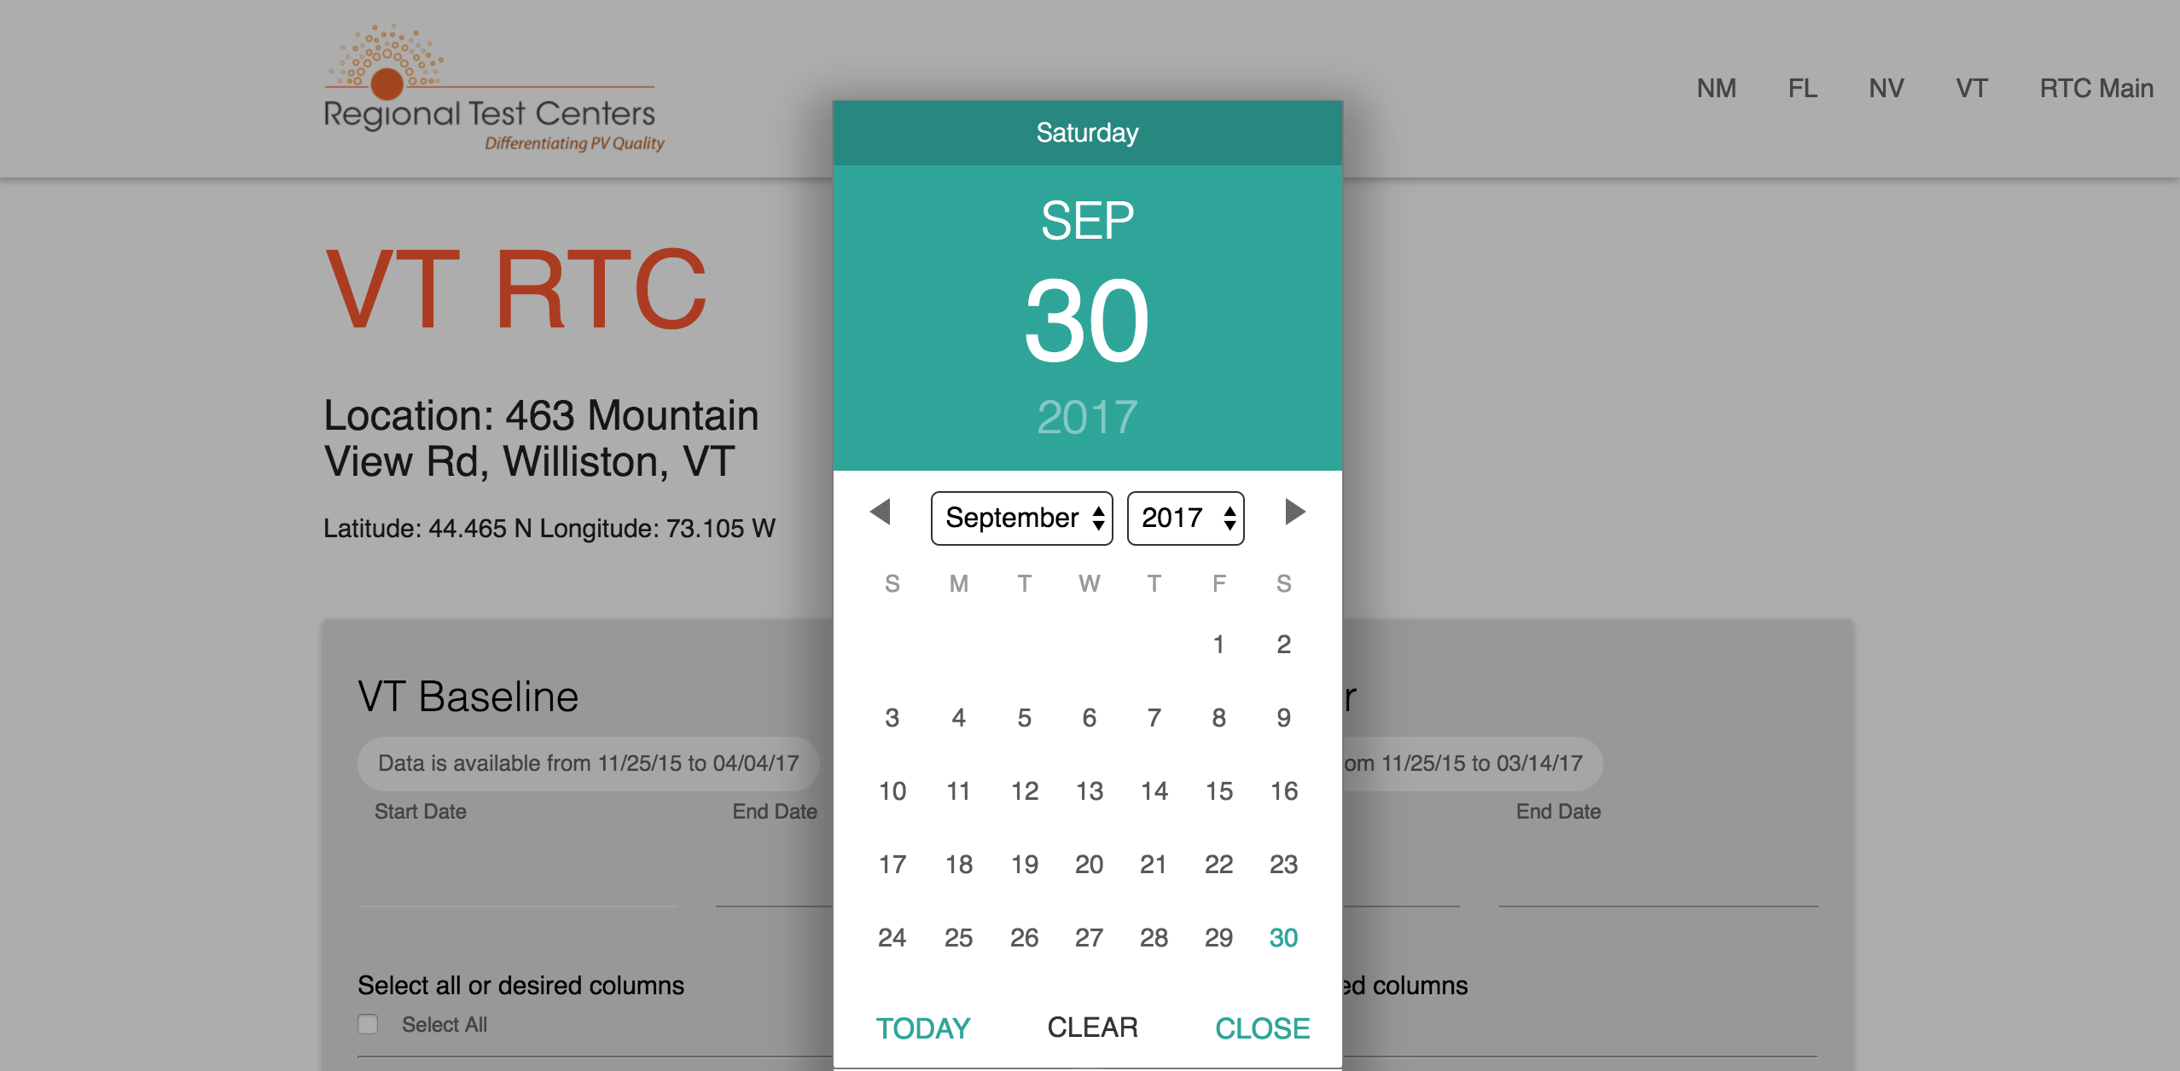

Figure 3: Date picker

After selecting a date range within the available dates, the user selects one or more data types and clicks “Build Query.” After the database builds the query, the user’s browser will prompt them to save a comma separated value (CSV) file. When the user opens the CSV, the file will reflect the data types as column headers, and the rows will correspond to each day within the specified date range.

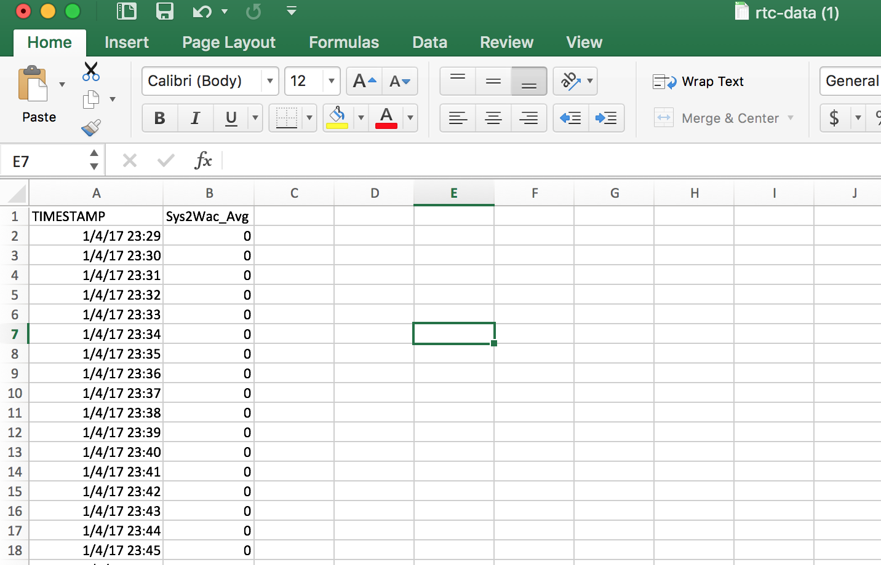

Figure 4: Sample CSV output

After the query has completed, the page redirects to the visualization of their previously selected data. This page allows users to interact with the visualizations, including adjusting the date range/time, zooming in or out to increase or decrease the focus on a particular set of data, and filter by toggling the specific modules that can be compared side by side. In addition, users can download a snapshot of the visualization in various different formats, including PNG, JPG, PDF, or SVG.

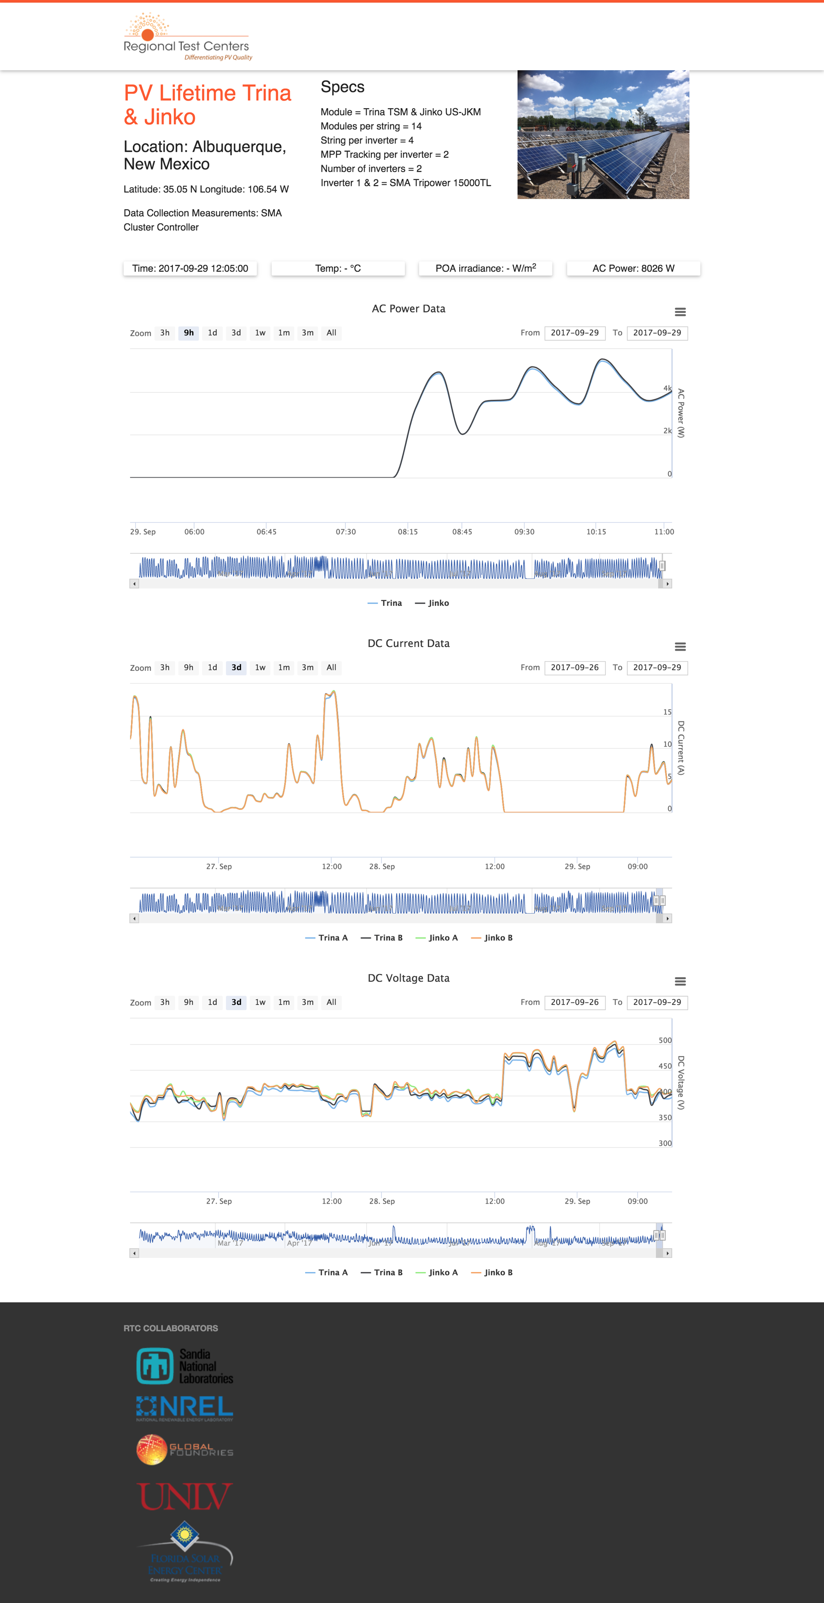

Figure 5: Data visualization

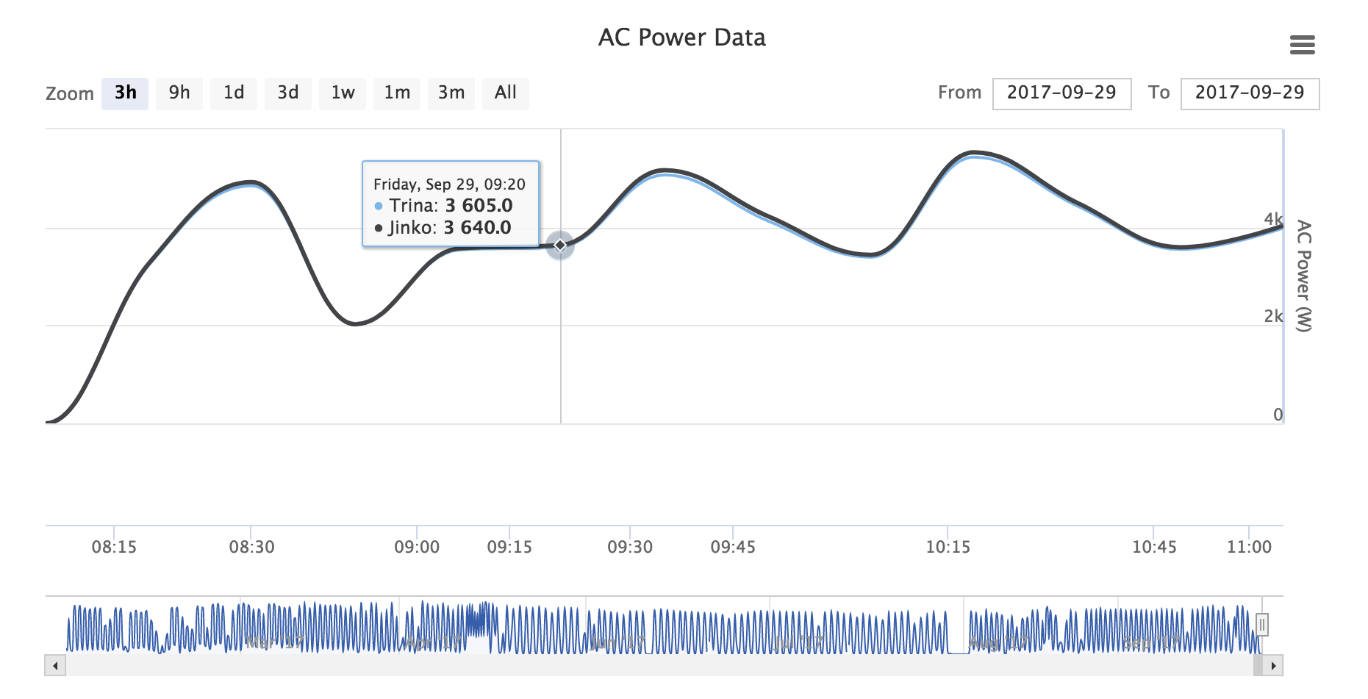

Figure 6: Data visualization hover state

## Web Links

The link to the prototype is: <https://share.sandia.gov/rtc-data> OR <http://ashleyotero.com/rtcdata/>. I do not control the uptime of the servers on the Sandia network, but the second URL is my own domain and server which serves as a backup.

Main data demo: <https://www.youtube.com/watch?v=nlm19XN67Zo>

Visualization Demo: <https://www.youtube.com/watch?v=BmR6VuvOabI>

# Tasks

## 3.1 Supported Tasks

1. Export data based on a specific set of user-defined criteria.
2. Find site specific information such as technical specifications and location.
3. Manipulate a visualization of data based on a specific set of user-defined criteria.

## 3.2 Unsupported Tasks

1. Authenticate as an authorized user by using a username and password.
2. View a dashboard of performance and reliability data for available systems.

These tasks were not included as it required too much effort for the scope of the project in terms of securing data and setting up authorization and authentication mechanisms. Also, the actual data I was given and used in the prototype did not include the proprietary data that would be required for this portion of the application.

# Reflection

I may have been a bit ambitious in putting together this prototype, but I am excited to present it to users for feedback and iterate on the design. The paper sketches I create for the last milestone appeared to meet all the requirements as agreed to by both myself and the stakeholders of the project, but once I started to code the interfaces themselves I realized how much was actually left undecided. I think creating more paper sketches after being able to see actual raw data may have informed my design more accurately and refined it before creating the high-fidelity version that I currently have.

I would definitely continue to use high fidelity prototypes as I didn’t receive a tremendous amount of feedback (neither positive nor negative) with the paper sketches. I think it was too hard for the users to visualize the interaction between drawings, or even imagine them as an actual interface within a web browser. I suspect they will have tons of comments and questions that will be illuminating to me during the next round of iterations. I also realized while testing my own system that I missed critical usability points like adding validation to the query builder, which I’m sure my users will catch. I only found this oversight upon preparing this report.

While this project was different than my usual workflow, I found myself with an unusual amount of freedom in design and development. I am used to having other designers or developers to bounce ideas off of during informal brainstorming sessions. I did not have the luxury of that team to rely on, but it did come with the trade-off of being able to make decisions definitively and move forward without much back-and-forth discussion with the stakeholders.

In my previous experience, the design and development teams were separated by skill set, which created a lack of ongoing collaboration. Ironically, my team is known for pioneering user-centered design as a part of our work, but much of our work is not reviewed in any meaningful capacity by the stakeholders or end users. They leave this process to us, as the experts, which is both helpful (as we don’t get caught up on simple aesthetics) and difficult (while trying to articulate specific requirements).

# References

Roth, R. E., Hart, D., Mead, R., & Quinn, C. (2016, May 9). Wireframing for interactive & web-based geographic visualization: designing the NOAA Lake Level Viewer. *Cartography and Geographic Information Science*.

Pernice, K. (2016, December 16). *UX Prototypes: Low Fidelity vs. High Fidelity*. Retrieved from Nielsen Norman Group: https://www.nngroup.com/articles/ux-prototype-hi-lo-fidelity/

Wilson, G., Aruliah, D. A., Brown, C. T., Hong, N. C., Davis, M., Guy, R. T., . . . Wilson, P. (2014, January 7). Best Practices for Scientific Computing. *PLoS Biol12*.